Data Structure and Algorithm

Laboratory Activity No. 5

Implementation of Arrays

|  |  |
| --- | --- |
| *Submitted by:* | *Instructor:* |
| Nerio, Hannah Grace A. | Engr. Maria Rizette H. Sayo |

August, 16, 2025

# Objectives

Introduction

Array, in general, refers to an orderly arrangement of data elements. Array is a type of data structure that stores data elements in adjacent locations. Array is considered as linear data structure that stores elements of same data types. Hence, it is also called as a linear homogenous data structure.

This laboratory activity aims to implement the principles and techniques in:

* Writing algorithms using Array data structure
* Writing a python program that can implement Array data structure

# Methods

* Write a Python program to create an array of 10 integers and display the array items. Access individual elements through indexes and compute for the sum.
* Write a Python program to append a new item to the end of the array. Original array: numbers = [1, 2, 3, 4, 5, 6, 7, 8, 9, 10]
* Write a Python program to insert a new item before the second element in an existing array. Original array: numbers = [1, 2, 3, 4, 5, 6, 7, 8, 9, 10]
* Write a Python program to reverse the order of the items in the array. Original array: numbers = [5, 4, 3, 2, 1]

Write a Python program to get the length of the array. Original array: numbers = [5, 4, 3, 2, 1]

# Results

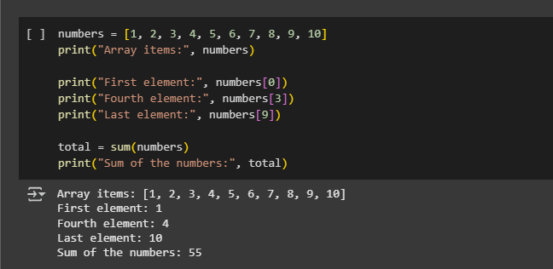

Figure 1 Screenshot of program

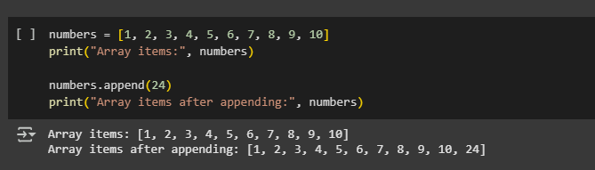

Figure 2 Screenshot of program

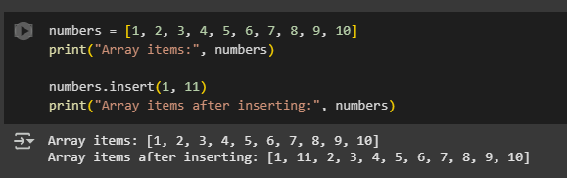

Figure 3 Screenshot of program

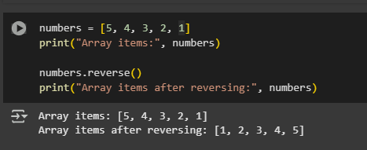

Figure 4 Screenshot of program

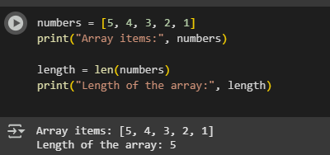

Figure 5 Screenshot of program

The first program asks the user to enter ten numbers, stores them in a list, and then displays the entire list. It also shows specific elements like the first, fifth, and the last number using their indexes, and finally calculates the sum of all numbers with the sum () function. The second program starts by letting the user create their own list by entering numbers, then asks for another number to add at the end. This is done with the append () function, and the updated list is displayed. The third program also lets the user create a list but then inserts a new number before the second element using the insert () function at index 1. After that, the modified list is shown. In the fourth program, the user first creates a list, and then the program reverses the order of the numbers using the reverse () function, printing the reversed result. Lastly, the fifth program allows the user to enter numbers to form a list, and it simply shows the total number of items inside it by using the len () function.

# Conclusion

The implementation of arrays in Python shows how lists can be used to store and manage multiple values efficiently. By performing operations such as appending, inserting, reversing, accessing, and counting elements. I learned how, accessing, and counting elements. I learned how arrays work not only in storing data but also in modifying and organizing it. This activity helped me understand the importance of arrays as a fundamental concept in programming and how they make handling data easier.

**References**

[1] Co Arthur O.. “University of Caloocan City Computer Engineering Department Honor Code,” UCC-CpE Departmental Policies, 2020.

[2] J. Doe, *Deep Learning with PyTorch*, Google Colab. [Online]. Available: https://colab.research.google.com/drive/1KUnjbW_lhStw2gGgr77G9qWzO5q7-k2K#scrollTo=N8vdWERscKI8